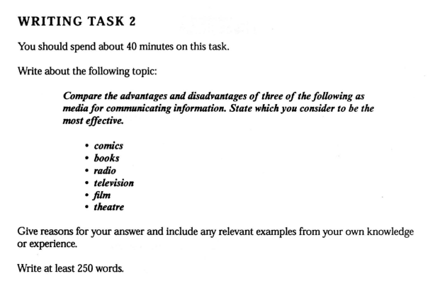

What Is The Most Effective Media?

We need to communicate information as social animals. It is more important because of the globalization. A long time ago our ancestors only could write letters to their families or friends and they could not imagine that to talk to other people just with a tool called a telephone.

Books were first invented and used by human beings, and then radio and television. Our way of communicating is becoming more and more effective. Apparently, television is the most effective, but why books still could not be replaced by radio or TV as the paper letters were replaced by e-mail? It is not only efficiency that is the most important thing. Only books can we read to feel the beautiful nature of literature. For thousands of years writers, scientists, psychologists and mathematicians have written a lot of great books which have driven us forward. Would it be presumptuous to only use a word to describe books? TV and radio are only for amusement.

**modified**

I choose books, radio and television which are quite typical for discussing the issue.

Books have the oldest history. It had been the main media for a long time before radio was invented. Those prominent writers, scientists and psychologists have written considerable books which are the most valuable treasures for human beings. Though books have advantages, it is not an effective way to deliver information because it need time to be printed.

Then the radio was invented. Audiences could know what is happening in other cities or other countries just in a few minutes by listening to the radio. That’s great progress in communicating information. Wherever you go, you can carry a portable radio with you. And you can learn about international news, sports news, etc. It is dull only to listen. There are illustrations in books, and what have we got from the radio? Consequently, a television was invented.

Television is one of the greatest inventions in history. We can watch live news on TV and know what happens in another part of the world simultaneously. We can cheer for our football team with the audience in the stadium at the same time. I know what it felt like when I was watching the FIFA World Cup. There isn’t any more effective media than television. The side effect is that people spend too much time watching TV, especially some children who are addicted to watching cartoons. To be addicted to something bad in an effective way.

In conclusion, television is most effective in communicating information, while books are still the right choice when you want to read novels, essays and research.